Single-Agent vs Multi-Agent Systems in Artificial Intelligence

A Comprehensive Report on Architecture, Functionality, and Real-World Applications

Prepared by: Ritankar Das

Date: October 2025

Index

| **Sr. No.** | **Topic** | **Page No.** |
| --- | --- | --- |
| 1 | Cover Page | - |
| 2 | Index Page | 2 |
| 3 | **Introduction** | 3 |
| 4 | **Single-Agent Systems** | 4 |
| 5 | **Multi-Agent Systems** | 6 |
| 6 | **Comparison** | 8 |
| 7 | **Applications in Healthcare** | 9 |
| 8 | **Applications in Mobility & Transportation** | 11 |
| 9 | **Applications in Customer Service** | 13 |
| 10 | **Challenges, Future Directions & Summary** | 15 |

1. Introduction

Artificial Intelligence (AI) stands as the defining technology of the 21st century, fundamentally revolutionizing industries by enabling systems to execute tasks that traditionally demand human-level intelligence. From complex decision-making to pattern recognition and predictive analytics, AI is transforming how businesses operate and how individuals interact with technology.

Within the vast landscape of AI, two foundational and contrasting paradigms dictate how intelligent behavior is structured and deployed: Single-Agent Systems (SAS) and Multi-Agent Systems (MAS).

### The Two Core Paradigms

1. Single-Agent Systems (SAS): The Master of Autonomy
   * SAS revolves around a single, unified intelligent entity (the agent) operating autonomously within its environment. Its primary objective is to achieve its goal by processing its perceptions and executing an optimal sequence of actions. These systems are characterized by centralized control and a focus on maximizing the agent’s individual utility, making them highly effective for well-defined problems with manageable complexity.
2. Multi-Agent Systems (MAS): The Power of Collaboration
   * In contrast, MAS involves multiple, interacting intelligent agents that must collaborate, compete, or coordinate to solve problems that are too large, dynamic, or distributed for any single agent to handle. This paradigm introduces social dynamics into AI, focusing on negotiation, communication, and decentralized decision-making. MAS excels in environments where robustness, scalability, and distributed knowledge are essential.

2. Single-Agent Systems in AI

## 

A Single-Agent System (SAS) represents the most fundamental architecture in Artificial Intelligence, focusing on an individual, self-contained intelligent unit designed to operate in isolation to achieve its goals.

### Core Philosophy and Structure

The entire premise of SAS is to maximize a specific performance measure or utility function through autonomous action. This single agent must be sophisticated enough to handle the complexity of its tasks without relying on external coordination.

#### Key Components in Detail:

1. Environment: This is the external world within which the agent exists and operates. It provides the problem space and the context for the agent's actions. The environment can be simple (like a chessboard) or complex (like a static warehouse floor), but crucially, it is the sole stage for the agent's performance.
2. Perception (Sensors): This is the input mechanism where the agent gathers information about its environment. For a robotic vacuum, this involves cameras and collision sensors; for a financial trading AI, it involves real-time market data feeds. The quality and timeliness of this perception directly limit the agent's effectiveness.
3. Reasoning Engine (The Brain): This is the central decision-making core of the agent. It takes the perceived data and applies complex algorithms, often driven by AI models (like search algorithms, logic programming, or deep learning models), to determine the best course of action. This module is responsible for planning, learning, and prediction.
4. Action (Actuators): This is the output mechanism—the set of tasks the agent can physically or digitally perform to affect the environment. A physical robot uses motors and grippers, while a virtual personal assistant uses output commands (like scheduling an appointment or replying to a query).

### The Workflow: A Centralized Cycle

The operation of an SAS is a continuous, centralized cycle:

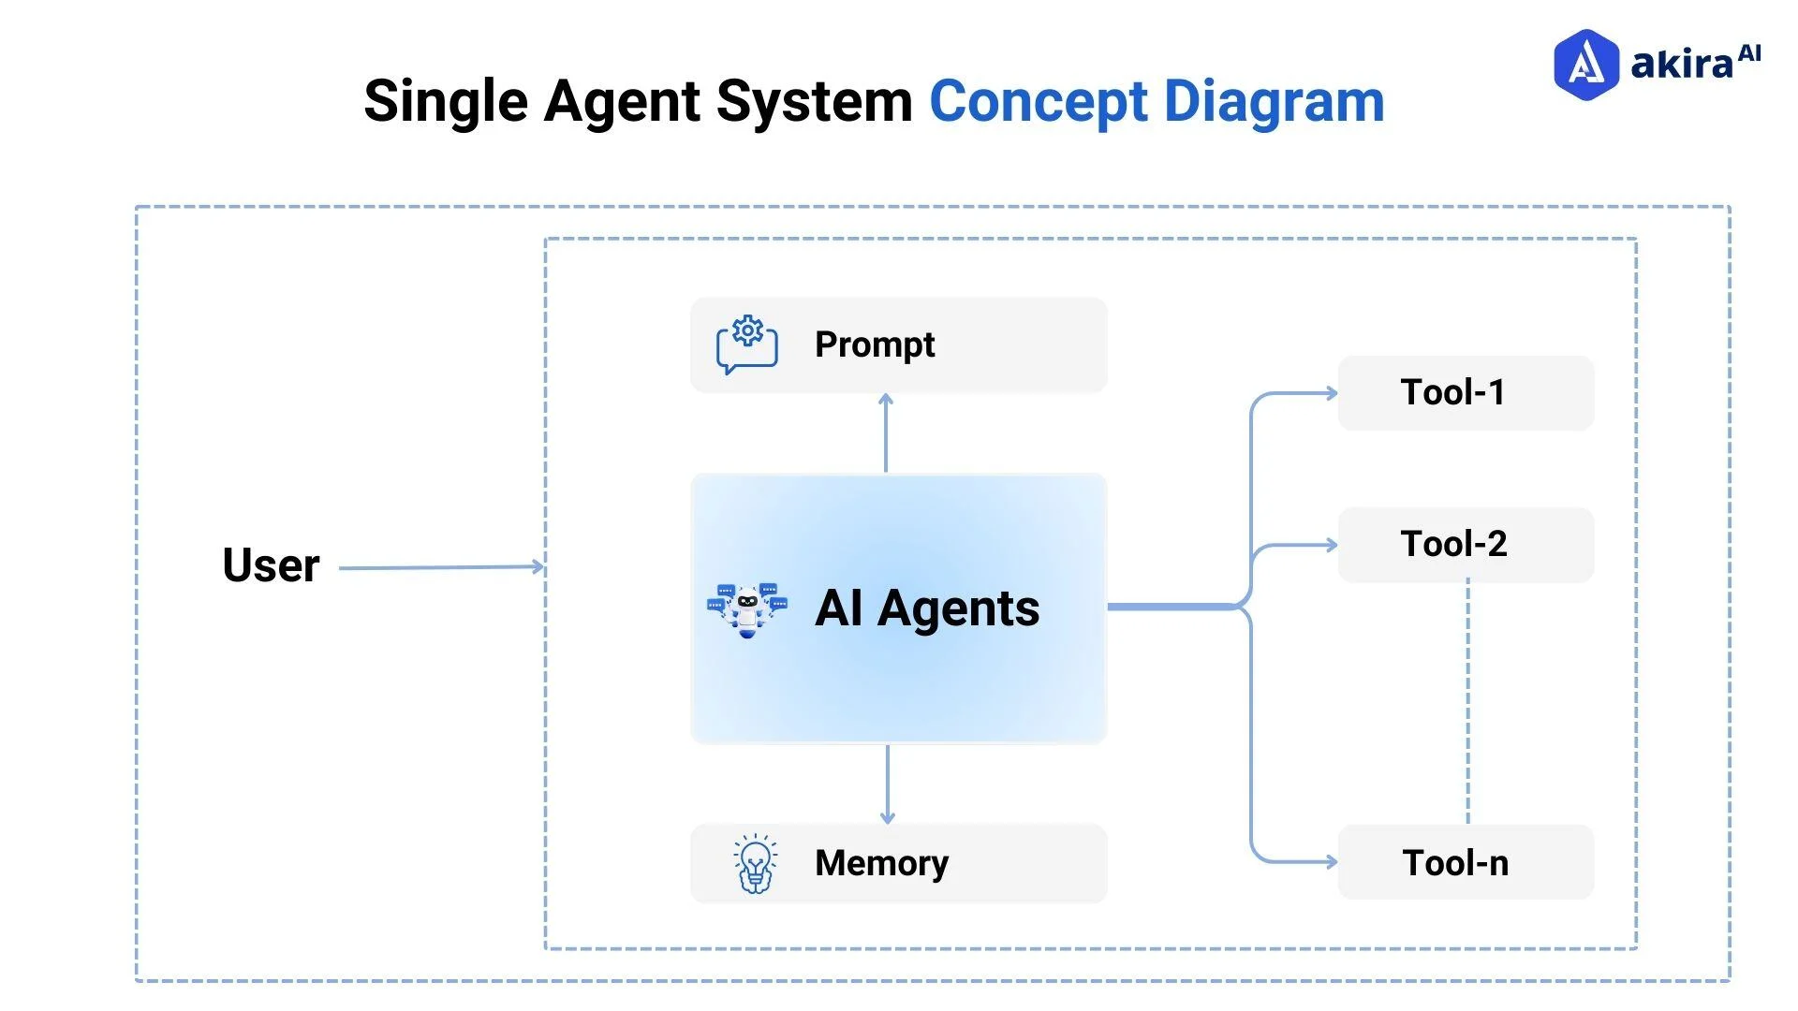

This workflow highlights the centralized control: every decision originates and terminates within the single agent.

* Example: A Chess-Playing AI
  + Environment: The 8x8 chessboard and the rules of the game.
  + Perception: It "sees" the current position of all pieces.
  + Reasoning Engine: It uses search algorithms (like minimax) and deep learning models (like AlphaZero) to evaluate millions of potential future moves.
  + Action: It communicates the coordinates of the chosen move.

### Strengths and Limitations

| Aspect | Description |
| --- | --- |
| Strength (Simplicity) | Easy to design, test, and debug because control is consolidated. The system is entirely predictable based on its programming. |
| Strength (Optimality) | Can often achieve a highly optimal solution for the specific, single task it was designed to solve. |
| Limitation (Robustness) | Low fault tolerance. If the single agent fails, the entire system fails. |
| Limitation (Scalability) | Poor performance in large or distributed environments. Trying to model and control an entire city's traffic with one agent is computationally impossible. |

SAS forms the foundational building block of AI, perfectly suited for tasks that are singular, predictable, and require deep, concentrated intelligence rather than broad, coordinated effort.

3. Multi-Agent Systems in AI

## 

Multi-Agent Systems (MAS) represent a more advanced and powerful paradigm in AI, moving beyond the capabilities of a solitary agent to harness the power of collective intelligence. This approach is essential for tackling problems that are inherently large-scale, dynamic, and distributed, mimicking complex human organizational structures or natural ecosystems.

### Core Philosophy: Distributed Intelligence

The key distinction of MAS is the decentralization of control and knowledge. Instead of one large, complex entity, the system is composed of several smaller, simpler agents, each capable of:

* Independent Reasoning: Every agent maintains its own internal state, goals, and decision-making logic, much like an SAS.
* Interaction: Agents must communicate and influence each other's behavior to contribute to a larger objective, which introduces concepts of negotiation and cooperation.

This structure allows MAS to solve problems where no single agent possesses all the necessary information or resources to achieve the global goal alone.

#### Key Architectural Components:

1. Communication Protocols (ACL): Agents need a standardized language (often based on formal logic or message passing) to exchange information, requests, and commitments. This is the Agent Communication Language (ACL), which facilitates negotiation and sharing of partial knowledge.
2. Coordination Strategies: These are the rules and mechanisms that govern how agents align their actions. Examples include:
   * Market-Based Systems: Agents bid for tasks or resources (like a contract net protocol).
   * Teamwork Models: Agents explicitly agree to act as a team, sharing a common goal and sub-goals.
3. Negotiation Mechanisms: When agents have conflicting goals or limited resources, they use negotiation to reach mutually acceptable compromises. This might involve bidding, argumentation, or bargaining.

### Agent Interactions and System Behavior

The final behavior of an MAS is an emergent property resulting from the individual decisions and interactions of its agents. The interactions fall into three main categories:

| Interaction Type | Description | Example |
| --- | --- | --- |
| Cooperative | Agents share a common goal and actively help each other to achieve it efficiently. | Swarm of drones collectively mapping a disaster zone. |
| Competitive | Agents have conflicting goals and strive to maximize their own utility at the expense of others. | Autonomous trading bots competing for the best stock price. |
| Neutral/Coexistent | Agents operate in the same environment but have independent goals; their actions may occasionally interfere. | Multiple autonomous vehicles sharing city roads. |

### The Decentralized Workflow

The MAS workflow illustrates the constant cycle of perception, action, and *inter-agent communication* within a shared environment:

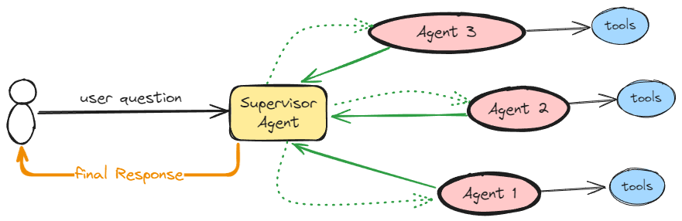

This decentralized, peer-to-peer interaction is what gives MAS its critical advantages:

* Robustness: If one agent fails, others can take over its task, preventing total system collapse.
* Scalability: Adding more agents can increase the system's capacity without drastically altering the existing structure.
* Flexibility: Agents can dynamically adapt their strategies based on the actions and communication of others.

4. Comparison between Single-Agent and Multi-Agent Systems

| Aspect | Single-Agent System (SAS) | Multi-Agent System (MAS) |
| --- | --- | --- |
| Number of Agents | One intelligent entity. | Multiple interacting intelligent entities. |
| Decision Making | Centralized (The single agent makes all decisions for the system). | Distributed (Each agent makes independent decisions, which collectively determine the system's outcome). |
| Communication | Not Required (Internal processes only). | Essential (Agents must communicate to coordinate, negotiate, and share partial information). |
| Scalability | Limited (Performance degrades quickly as the problem size or complexity increases beyond the agent's capacity). | High (New agents can be added modularly to handle increased load or scope). |
| Fault Tolerance | Low (If the single agent fails, the entire system stops functioning). | High (If one agent fails, others can often reallocate its tasks or continue operating, leading to graceful degradation). |
| Real-world Use | Simple Automation (e.g., individual optimization, specific diagnostics, static game playing). | Complex Coordination (e.g., traffic management, supply chain optimization, industrial automation). |

5. Applications in Healthcare

## 

The healthcare industry is experiencing a profound transformation driven by Artificial Intelligence, where intelligent agents are deployed to enhance efficiency, accuracy, and patient outcomes. The choice between a Single-Agent System (SAS) and a Multi-Agent System (MAS) in this sector depends on whether the task requires deep, focused intelligence or broad, distributed coordination.

### Multi-Agent Systems (MAS) for Holistic Management

MAS addresses the inherent complexity and distributed nature of hospital operations and patient care pathways. These systems involve specialized agents collaborating to manage the overall workflow and resource allocation.

#### 1. Hospital Workflow and Resource Management

The healthcare environment is a prime candidate for MAS, where the system ensures efficient operation across multiple, semi-autonomous departments.

| Agent Type | Role and Interactions | Contribution to Healthcare |
| --- | --- | --- |
| Scheduling Agent | Coordinates with Patient, Doctor, and Resource Agents to optimize appointment times and facility usage. | Reduces patient waiting times and minimizes resource conflicts (e.g., operating room usage). |
| Lab Agent | Receives test requests from Doctor AI, schedules technicians, manages sample priority, and reports results back. | Speeds up the diagnostic pipeline and ensures timely communication of critical data. |
| Pharmacy AI | Receives e-prescriptions, checks for drug interactions (collaborating with Doctor AI), manages inventory, and notifies the patient of dispensing status. | Enhances medication safety and reduces inventory waste. |

#### 2. Personalized and Remote Patient Monitoring

MAS can integrate data from various sources outside the clinic:

* Wearable/Sensor Agents: Collect real-time vital signs (heart rate, glucose levels).
* Triage Agent: Analyzes this continuous stream of data for anomalies. If a pattern indicates a potential emergency, the Triage Agent automatically communicates with the Doctor Agent to flag the situation and alert the Emergency Services Agent. This distributed, reactive system ensures immediate, coordinated response.

6. Applications in Mobility and Transportation

## 

The domain of Mobility and Transportation offers one of the clearest distinctions in the practical deployment of Single-Agent Systems (SAS) versus Multi-Agent Systems (MAS). AI is used here to optimize everything from individual vehicle control to city-wide traffic flow management.

### Multi-Agent Systems (MAS): Orchestrating the Traffic Ecosystem

MAS is essential for managing the dynamic, large-scale, and cooperative nature of urban and regional transportation networks. Here, multiple agents (vehicles, traffic lights, monitoring sensors) coordinate to achieve a global system optimization.

| Agent Type | Role and Interactions | System Optimization |
| --- | --- | --- |
| Vehicle Agents | Autonomous cars that communicate their intended routes, speed, and emergency braking intentions to surrounding vehicles and infrastructure agents. | Enables V2V (Vehicle-to-Vehicle) and V2I (Vehicle-to-Infrastructure) communication, significantly reducing accidents and congestion. |
| Traffic Light Agents | Actively communicate with nearby Vehicle Agents to gauge traffic density and dynamically adjust signal timing across a network of intersections. | Reduces idle time at intersections, optimizing the *flow* of traffic rather than just treating a single intersection. |
| Routing Agents | Reside in a central system, collecting data from all Vehicle and Sensor Agents, and calculating global optimal routes in real-time. | Can reroute vehicles around accidents or heavy congestion before drivers are aware, optimizing city-wide transit time. |
| Ride-Sharing/Fleet Agents | Coordinate a fleet of vehicles (taxis, buses, or autonomous pods) to efficiently meet demand patterns across a metropolitan area. | Maximizes vehicle utilization and minimizes operational costs through complex scheduling and task allocation. |

### Key Advantages of MAS in Transportation

1. Congestion Alleviation: By having agents communicate (e.g., "I will reach the intersection in 30 seconds"), the system can coordinate vehicles through intersections without ever stopping (platooning or synchronized flow), something impossible for a set of purely independent SAS vehicles.
2. Increased Safety: MAS allows vehicles to anticipate the actions of others, leading to smoother merging and more robust emergency response coordination.
3. Scalability: The system can easily integrate new vehicles, traffic lights, and public transit units without requiring a complete overhaul of the centralized control (which would be the bottleneck for a massive SAS).

7. Applications in Customer Service

## 

The customer service domain has been dramatically reshaped by AI, moving from simple automated responses to complex, personalized interactions. Both Single-Agent Systems (SAS) and Multi-Agent Systems (MAS) play crucial, distinct roles in this transformation.

### Multi-Agent Systems (MAS): Handling Complexity and Escalation

MAS is deployed when a customer interaction is complex, requires external data, or needs coordination across multiple company departments or systems. The goal is to ensure a seamless, high-quality resolution for the customer.

The service request initiates a coordinated workflow among specialized agents:

| Agent Type | Role and Interactions | Customer Service Value |
| --- | --- | --- |
| Triage Agent | First-line agent; analyzes customer intent and complexity. If complexity is high, it initiates contact with specialized agents. | Ensures requests are accurately routed to the right specialist without unnecessary human intervention. |
| Knowledge Agent | Responsible for searching and retrieving relevant documentation, policy details, or troubleshooting steps from company databases. | Provides accurate, consistent, and up-to-date information to the human or other AI agents. |
| Fulfillment Agent | Interacts with backend systems (e.g., inventory, billing, logistics) to process transactions, refunds, or service changes. | Automates complex actions like issuing a refund or updating a shipping address immediately. |
| Human Interface Agent | Manages the seamless handoff of a conversation to a human agent, providing the human with a full summary of the AI interaction history. | Maintains context and reduces the need for the customer to repeat information during escalation. |

### The Integrated MAS Workflow

The MAS allows for a dynamic and robust customer journey:

1. A customer initiates a complex query (e.g., "I need to return my item, but I don't have the original packaging, and I want a store credit").
2. The Triage Agent recognizes the complexity (return policy + store credit + missing packaging).
3. It contacts the Knowledge Agent to retrieve the relevant return policy and the Fulfillment Agent to check the customer's purchase history and current stock levels.
4. The agents communicate and negotiate (e.g., "Can we offer a partial credit for a damaged return?").
5. If a consensus is reached, the Fulfillment Agent processes the credit. If not, the Human Interface Agent summarizes the case and seamlessly routes it to a human supervisor for final approval.

8. Challenges and Future Directions

### Challenges

* MAS Complexity: High communication overhead and difficulty in guaranteeing global optimality.
* SAS Brittleness: Lack of adaptability when faced with novel situations outside training.
* General Issues: Lack of Explainability (XAI) in complex decisions and mitigating ethical bias in training data.

### Future Directions

The future lies in Hybrid Systems, where sophisticated SAS are organized and managed by MAS structures. This is being driven by advances in Deep Multi-Agent Reinforcement Learning (MARL), enabling agents to learn optimal, complex coordination strategies organically rather than being explicitly programmed.

The strategic success of AI hinges on recognizing that while SAS provides deep, focused intelligence, MAS offers the robust, scalable coordination required to manage the interconnected systems of the modern world.

9. Summary and Conclusion

Single-Agent and Multi-Agent Systems represent two ends of the AI architecture spectrum. Single-Agent Systems are ideal for focused, independent tasks, while Multi-Agent Systems enable distributed problem-solving and collaboration. As industries evolve, MAS are increasingly becoming the backbone of complex AI ecosystems — from healthcare networks to autonomous transportation and intelligent enterprise operations.